Made in God's Image: Part Two

Written by The Rev. Dr. Mark D Atkinson
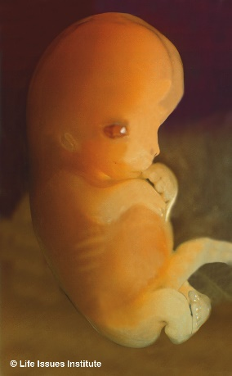What does Scripture teach regarding the nature of human life and the unborn? This is the second of six Scriptural themes that indicate why we are pro-life.
B. The meaning and purpose God has for each human person begins before birth
Genesis 4:1; I Samuel 1:20; Matthew 1:20 - 21; Job 31:15; Psalm 139:13 - 16; Jeremiah 1:5
Your eyes saw my unformed substance; in your book were written, every one of them, the days that were formed for me, when as yet there was none of them. --Psa. 139:16
I suspect that one key reason why support for abortion rights has been losing ground in recent years is because of changing technology. On one hand, our hospitals are able to support infants prematurely as early as twenty-four weeks of gestational development and, on the other hand, sonogram ultrasound technology provides very clear photographic evidence that the developing baby is undeniably human. We can see with our own eyes that the baby in the womb is a baby.
We believe that all human life has value because we are made in the image of God. Similarly, we believe that all human life has meaning, because we are made according to the purpose of God. God's purpose for our lives is established before we are born.
We see repeatedly in the scriptures the announcements of the significance of the lives of those who have not yet been born. There is a destiny behind the lives of these men and women. They will have a part in God's unfolding of his purpose and plan. Those purposes and plans begin in the womb or even before, in the mind of God.
Here are some examples of God's prenatal planning. The patriarchal wife Rebekah is pregnant with twins, Jacob and Esau. She is told prophetically that two nations are struggling within her womb. The prophet Samuel was born to be dedicated to God's work from birth. In Matthew's gospel, John the Baptist, while still in his mother's womb, jumps when he hears the voice of Mary, the mother of Jesus. God says to the prophet Jeremiah, Before I formed you in the womb, I knew you. The Apostle Paul understood his calling and purpose before God to have been fixed before birth. In Galatians 1:15 he writes, God...set me apart from my mother's womb.... Of course, the greatest example of God's purposes established before birth is seen in the life of the Lord Jesus himself. He is one whose meaning and purpose for his life was established and set long before his birth.
We do not know what God has in store for the lives of the little ones he gives to us. He sets their purpose before life begins. Life is lived forward. Even children born into the direst circumstances can be used by God in great and significant ways.
God places a high value on human life. Humans are the crown of creation and have been given dominion over the earth. The meaning and purpose of each human life begins before birth.ÂÂÂ Next, God forbids the killing of innocent life.

This series is from a sermon preached by The Rev. Dr. Mark D. Atkinson, at Fairview Presbyterian Church (EPC) in Glenmoore, PA, on Sanctity of Human Life Sunday, January 20, 2013. To read part one of the series click the link below.
Articles posted in this series:
Made in God's Image: Part One
God forbids us to kill innocent life: Part Three
Ahead in this series:
Part 4: God requires us to protect and care for the needy and the helpless
Part 5: Scriptural teaching regarding the value of human life and our responsibility to protect and care for innocent human life applies in every case
Part 6: God freely offers forgiveness and restoration to the repentant

