Made in God's Image: Part Three

Written by The Rev. Dr. Mark D Atkinson
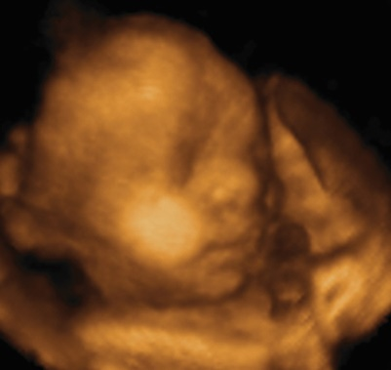What does Scripture teach regarding the nature of human life and the unborn? What are the implications of this teaching for the taking of innocent life? Third of six articles on Scriptural themes that indicate why we are pro-life.
C. God forbids us to kill innocent life
Exodus 20:13; Deuteronomy 5:17; Amos 1:13; Leviticus 18:21
"Thus says the LORD: For three transgressions of the Ammonites, and for four, I will not revoke the punishment, because they have ripped open pregnant women in Gilead, that they might enlarge their border." —Amos 1:13
There is a moment in the story of the Lord of the Rings when, upon discovering that the wretched and wicked creature Gollum is following their trail, Frodo wishes that his uncle Bilbo had killed Gollum when he had the opportunity to do so, many years before. Gandalf chastises Frodo asking, "Can you give life? Do not be so quick to take it away." Only God should decide death and life. Part of the terribleness of abortion is not only that it is the killing of a life, but that in choosing abortion we put ourselves before God: deciding who will live and who will die. We take a role that is reserved for Him.
As you know the Ten Commandments are divided into two tablets. The first tablet speaks of God and our human duty towards him: make no idols, do not take God's name in vain, worship no other Gods. The second tablet speaks of human relationships: do not steal, do not lie, do not murder. The distribution of the Ten Commandments is uneven: four commands on the first tablet and six on the second tablet. When Jesus summarizes the message of the law and prophets he says that it is to 1) love the Lord, Thy God, with all your heart, soul and mind (the first tablet); and to love your neighbor as yourself (the second tablet).
The Bible is not naive. Ours is a fallen and corrupt world. Killing, though forbidden, is sometimes necessary. The state has been given the power of the sword. Where killing is sometimes justified is only when it is mediated through the state for the restraint of evil: Just War, capital punishment, and self-protection. In capital punishment, it is the prior action of the one on death row that is the basis upon which the punishment is given. In other words, the criminal's actions make him culpable for his death sentence. It is what he has done, not who he is, that lands him on death row. In contrast, with abortion, it is never the actions of the pre-born person that are at issue, but rather his very existence. It is that he is, not what he has done, that lands the baby in the abortionist's abattoir.
Those who favor abortion understand that the Biblical prohibition against the taking of innocent life has been woven into the very fabric of our society. We know that it is not right to take innocent life. There is no debate on this issue. It is for this reason that the pro-abortion folk are forced to rely instead upon verbal sleight of hand: they are pro-choice, not pro-abortion; they call the baby a 'fetus' (which is Latin for baby); they rename abortion a 'termination of pregnancy.' At the same time, the sleight of hand does not change the truth. Life begins at conception. The sperm and egg meet and create a new genetic code and a new person, a new being, a new life.
God has created mankind in his image. Human beings have worth and value in the sight of God. A human person's worth and value begins before birth, for God establishes our place and purpose in his world. God prohibits the taking of innocent life. Next, God requires us to protect and care for the needy and the helpless.

This series is from a sermon preached by The Rev. Dr. Mark D. Atkinson, at Fairview Presbyterian Church (EPC) in Glenmoore, PA, on Sanctity of Human Life Sunday, January 20, 2013.
Previous posts in this series:
Made in God's Image: Part One
Made in God's Image: Part Two
Still to come in the series:
Part 4: God requires us to protect and care for the needy and the helpless
Part 5: Scriptural teaching regarding the value of human life and our responsibility to protect and care for innocent human life applies in every
Part 6: God freely offers forgiveness and restoration to the repentant

